# Activity 10.1: Creating a Docker Image

1. Screenshot of the Dockerfile added to the folder “Activity 10.1 - Docker Image”

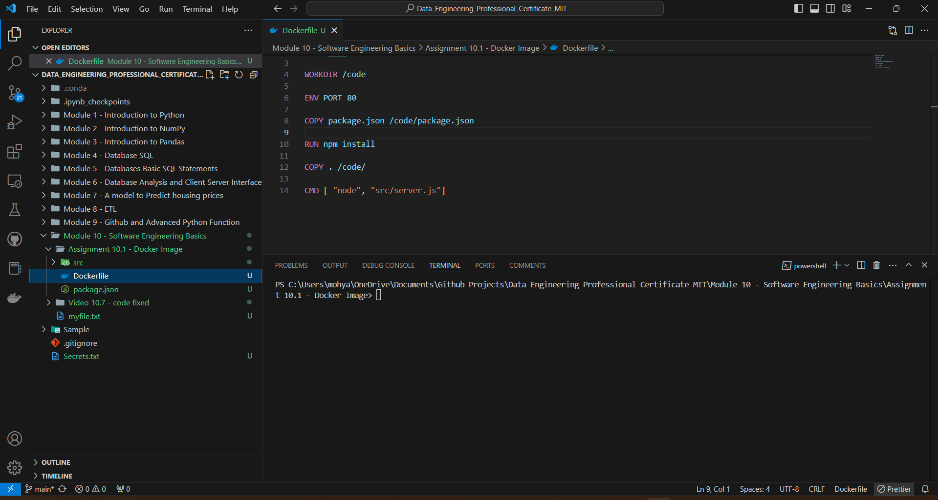

1. Screenshot of running the docker build command

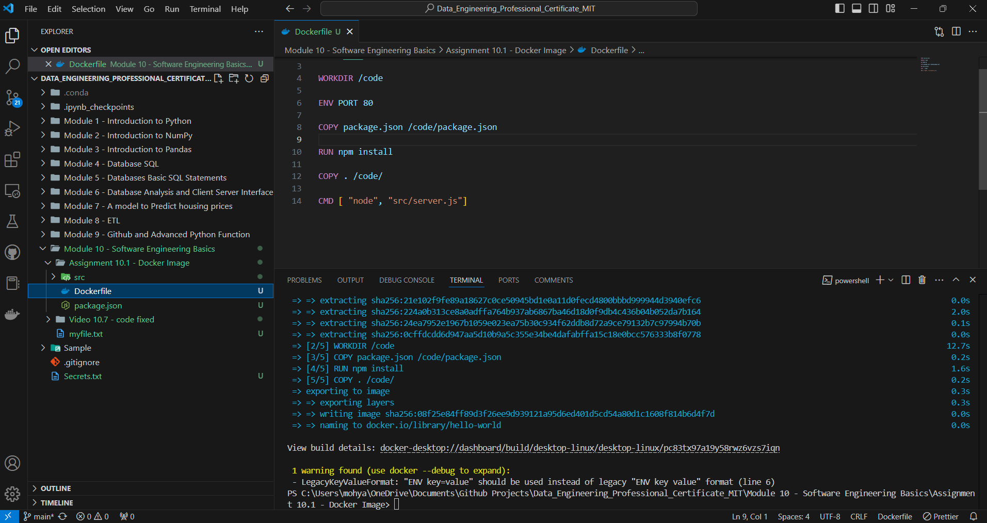

1. Screenshot of running the docker image command

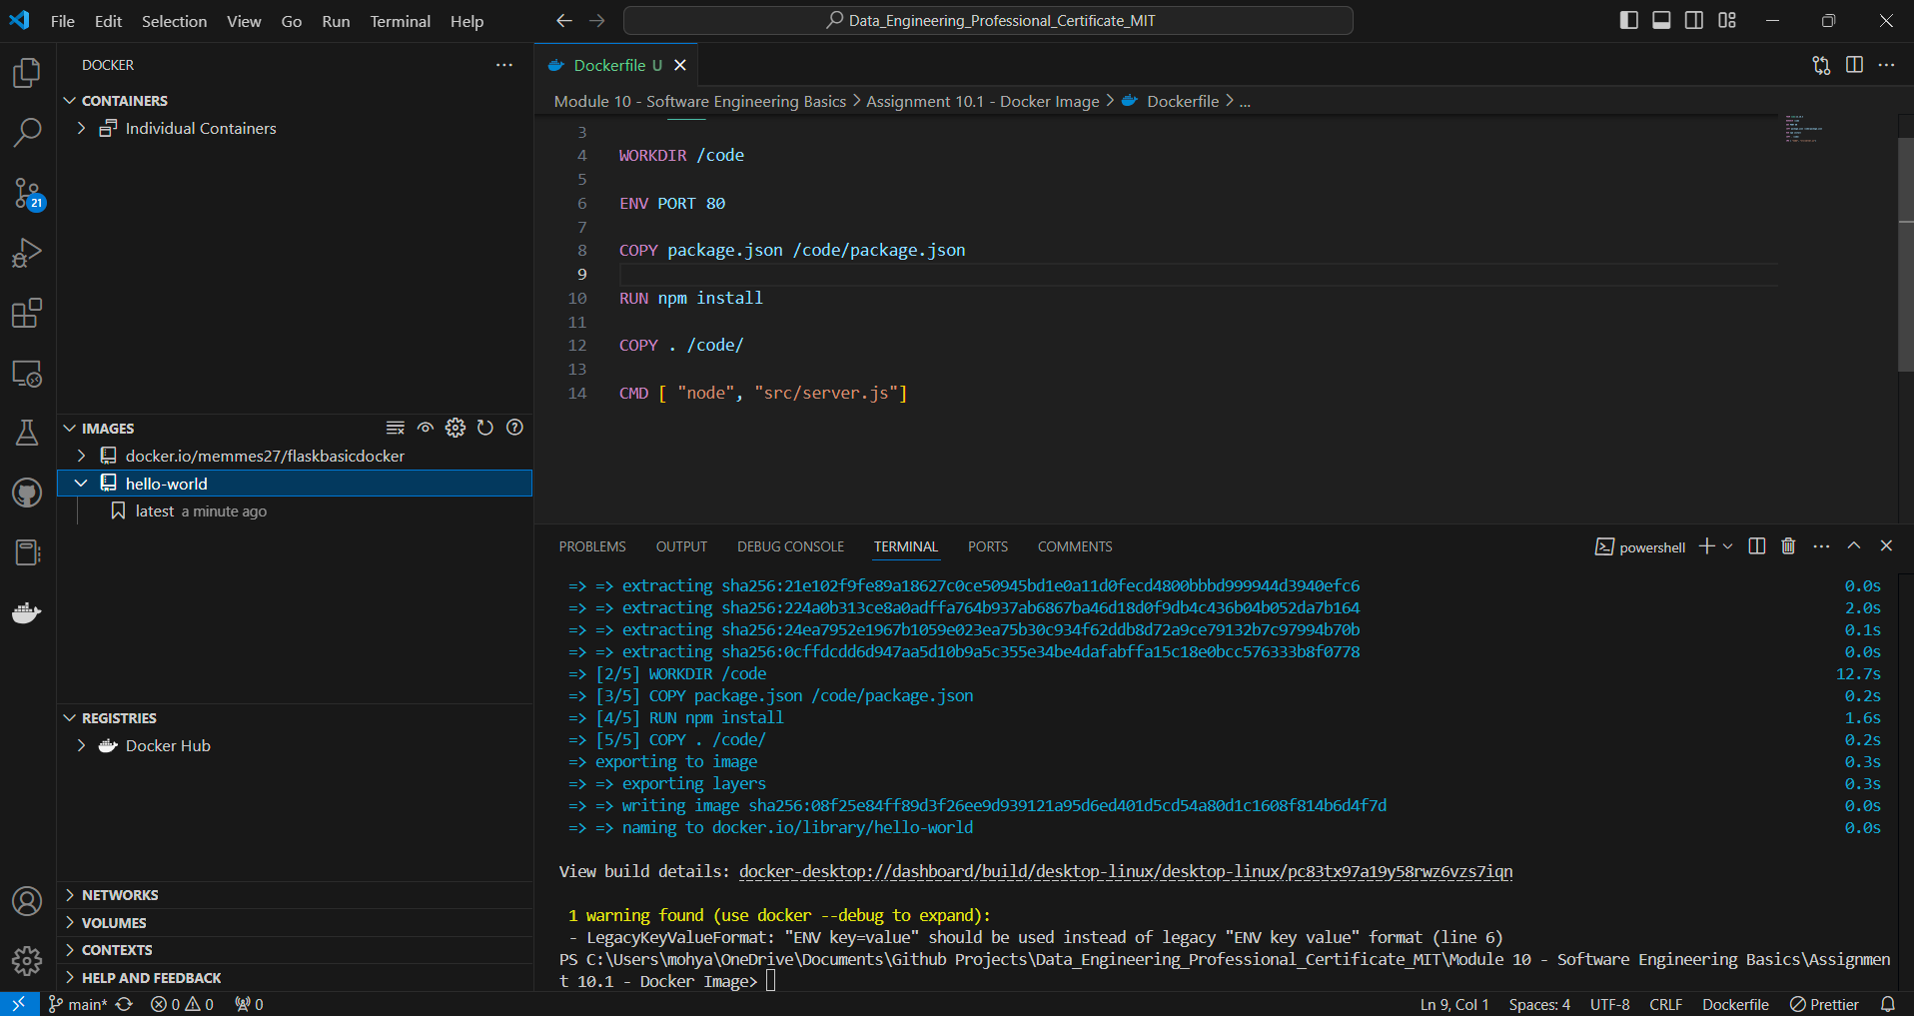

1. Screenshot of running the docker run command to run the image in the container

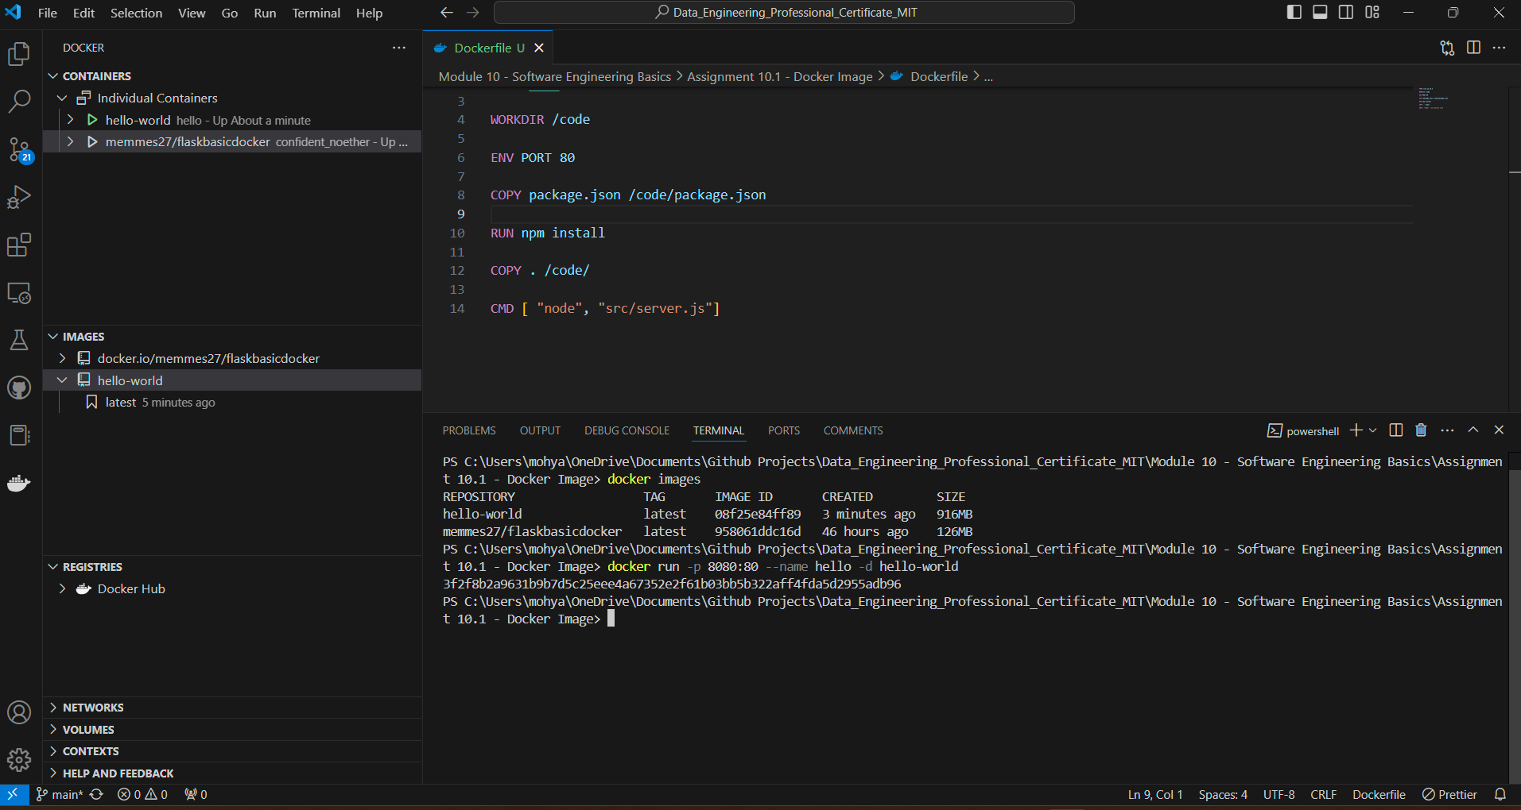

1. Screenshot of a web browser to show <http://localhost:8080/>. The web page should display “Hello World – my first Docker Image!”

